Azure KeyVault
You can access Azure Key Vault by first ensuring you have an Azure subscription and then configuring authentication for users or applications through Microsoft Entra ID.
Access is granted by either assigning an access policy in the portal or using Role-Based Access Control (RBAC), where you can assign specific permissions like "Get" and "List" secrets to a security principal (e.g., a service principal, user, or managed identity).

using Azure.Identity;
using Azure.Security.KeyVault.Secrets;
using Microsoft.Extensions.Configuration; // Required for configuration-based access

public class KeyVaultService
{
private readonly SecretClient _secretClient;
private readonly IConfiguration _configuration; // Inject IConfiguration

public KeyVaultService(IConfiguration configuration)
{
_configuration = configuration;

// Determine the authentication method based on configuration
var keyVaultUri = _configuration["KeyVault:VaultUri"]; // Get Key Vault URI from app settings

if (string.IsNullOrEmpty(keyVaultUri))
{
throw new ArgumentNullException(nameof(keyVaultUri), "Key Vault URI is missing in configuration.");
}

// Default to using managed identity if available
var credential = new DefaultAzureCredential();

// If using service principal, configure credentials here (example)
// var clientId = _configuration["KeyVault:ClientId"];
// var clientSecret = _configuration["KeyVault:ClientSecret"];
// var tenantId = _configuration["KeyVault:TenantId"];
// if (!string.IsNullOrEmpty(clientId) && !string.IsNullOrEmpty(clientSecret) && !string.IsNullOrEmpty(tenantId))
// {
// credential = new ClientSecretCredential(tenantId, clientId, clientSecret);
// }

_secretClient = new SecretClient(new Uri(keyVaultUri), credential);
}

public async Task<string> GetSecretAsync(string secretName)
{
try
{
KeyVaultSecret secret = await _secretClient.GetSecretAsync(secretName);
return secret.Value;
}
catch (Exception ex)
{
// Handle exceptions appropriately (e.g., logging, custom error handling)
Console.WriteLine($"Error retrieving secret: {ex.Message}");
throw; // Re-throw or handle as needed
}
}
}

Health Check in dotnet core api:
Link:
Health Checks in ASP.NET Core - Code Maze
Application Health Check Using ASP.NET Core

Using these health checks, we can be notified of outages before customers and reduce the impact of outages by
fixing them or informing the customer about the ongoing outage with time which leads to gaining trust.

Health Checks allow us to determine the overall health and availability of our application infrastructure. They are exposed as HTTP endpoints and can be configured to provide information for various monitoring scenarios, such as the response time and memory usage of our application, or whether our application can communicate with our database provider.
Health Checks are not binary. What if our application is responding, but slower than expected? ASP.NET Core provides us with three different Health Check levels:
- Healthy – our application is healthy and in a normal, working state.
- Unhealthy – our application is unhealthy and is offline or an unhandled exception was thrown while executing the check.
- Degraded – our application is still running, but not responding within an expected timeframe.

Application Insights Implementation:
https://www.c-sharpcorner.com/article/using-azure-application-insights-for-exception-logging-in-c-sharp/

Azure Application Gateway and API Management (APIM) serve distinct purposes in managing and securing web traffic and APIs. While they can complement each other in certain scenarios, their functionalities and use cases differ significantly.
Azure Application Gateway
Application Gateway is a layer 7 load balancer designed to manage web traffic to applications. It provides features such as:
- Web Application Firewall (WAF): Protects against common web vulnerabilities, including OWASP Top 10 threats.
- Path-based Routing: Routes traffic based on URL paths to different back-end services.
- SSL Termination: Offloads SSL decryption to improve performance.
- Single Entry Point: Acts as the only exposed endpoint to the internet, enhancing security.
It is ideal for scenarios where you need to secure and route traffic to web applications, especially when protecting against web-based attacks or managing complex routing rules.
Azure API Management (APIM)
API Management is a hybrid, multi-cloud platform for managing APIs. It provides tools to expose, secure, and monitor APIs effectively. Key features include:
- API Gateway: Acts as a reverse proxy to expose APIs securely.
- Authentication and Authorization: Supports Azure AD, subscription keys, and JWT tokens for API access control.
- Rate Limiting and Throttling: Controls API usage to prevent abuse.
- Developer Portal: Offers a self-service portal for API consumers.
- Policy Framework: Enables request/response transformation, caching, and custom logic.
APIM is best suited for organizations exposing APIs to internal or external consumers, offering robust API lifecycle management and security.
When to Use Each
- Use Application Gateway when managing web traffic to applications, requiring WAF protection, or implementing advanced routing for web apps.
- Use API Management when exposing APIs to users or systems, requiring API-specific features like rate limiting, authentication, and developer portals.

Azure blob Hot vs Cold
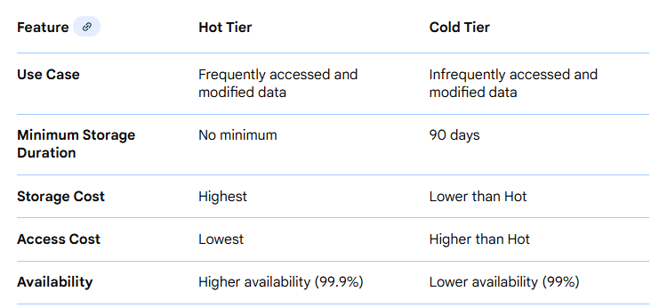

Managed Identity vs Service Principal: Overview of Key Differences*

